You must be feeling the pain of a wet basement! Having called on so many homeowners over the years and experiencing a wet basement myself, I know what you are going through. Seeing many of your prized posessions being destroyed by a leaking basement wall can be heartbreaking. Even worse if you have a finished basement.
A wet basement is fraught with dangers from electrocution, slip and fall, structural damage, destroyed furnace and water heater, to the unhealthy condition of a sick home syndrome full of mold and mildew affecting your children and pets.
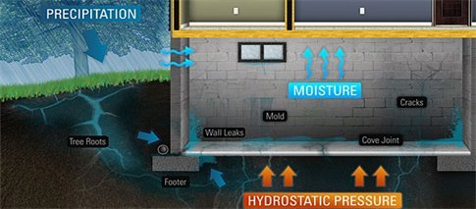
Basement water problems cannot be ignored, if you have noticed foundation leaks in your basement or have the beginning of mold growth in any area of your house making repairs early will not only save you money, but will also protect your property from significant damage and your families health from the serious affects of mold growth. There are a number of causes for water leakage and mold growth, and investing in having a professional waterproof your home is the best solution.
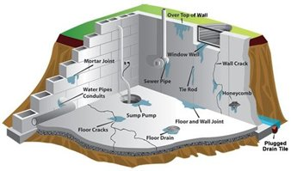
Water works its way into the hollow cavities of the blocks. pushing itself downward to the bottom level of the basement wall where the wall meets the floor and the water then enters your basement floor.
(877) 376-1815

Seepage, is a common problem which may occur in combination with cracks. Seepage often is caused by surface water filling the clay bowl and pressing against the exterior of basement walls.
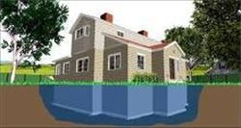
Ineffective or poorly maintained drainage systems don't relieve seepage pressure. Although a dry basement may have serious cracks and structural problems, while a leaky basement may be structurally sound. Cracks, movement and leaks are not always related. The false water table causes seepage problems. Lateral pressure from wet soil at eight feet below grade gets approx. 15000 pounds per square foot against the basement walls. This pressure causes leaks, cracks and structural failures.

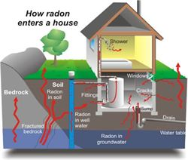
Structures built above karst cavities are prone to infiltration of radon due to fluctuations in atmospheric pressure (Ruthven, C. et. el., 2002). Also, it is believed that considerable amounts of radon are produced with in the soils overlying karst bedrock. This radon is thought to be released into water reservoirs beneath the surface following heavy rain events (Savoy, L. et el,)
Radon gas in groundwater seeping through your leaking basement wall and floor because of hydrostatic pressure causing a wet basement can be harmful to your health.
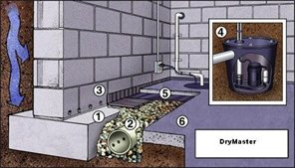
To install an interior subfloor pressure relief system, (1) an approximate 12" wide by 10" deep trench will be excavated in the floor along the cove base and according to plan. (2)The trench will be lined with a filter paper and a 4" peforated subsoil drainpipe will be installed in the trench encased in "drain stone". (3) In the event of cinder block foundation walls only, weep holes will be drilled into every core and seam of the first course of block to aide in drainage. (4) The drain pipe is attached to a sump pump system which will discharge the water into a pvc pipe which will go through the foundation wall to the outside. (5) The weep holes will be covered by a drain core board which will extend above and below the floor. (6) The trench will then be concreted over flush with the floor.
When basements get wet it's not long before you will see the growth of mold and mildew.Molds have the potential to cause health problems. Molds produce allergens (substances that can cause allergic reactions), irritants, and in some cases, potentially toxic substances (mycotoxins). 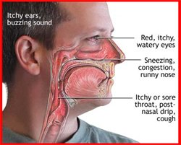

“I was impressed from my first phone call which was informative. Your basement inspector Fred was professional, he had a great manual which he went through with my husband and I. DryMaster was the best price we got.The workmen were knowledgeable and well equipped. We haven't had any leaks since getting the job done.I would highly reccomend Drymaster. Thank you!”
Dorothy from Clifton, N.J.

“In this day and age, it’s hard to find a company you can trust. I found DryMaster at the Freehold Home Show. The quality of service I received was outstanding. The work was done in a timely fashion and my home was left clean. My basement is dry and fresh smelling! Keep up the good work!”
Bill from Howell, N.J.

"The quality and professionalism of the team working in my home was top notch."
Karen from Freehold

"Thank you! After some very heavy rain in the last week, I have not had any water come in at all! I only wish I had called you sooner."
Barbara from Wilmington

"We are so glad we visited your booth at the Vineland Home show. We were afraid that we couldn't afford to waterproof our basement. DryMaster made it affordable. Now our basement is dry and fresh smelling."
Connie from Vineland

"On Time and courteous! We appreciate the thorough inspection, the detail, and of course the price!
Brian and Karen from Waldwick

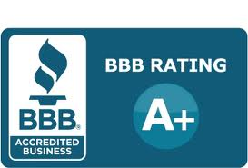

ADVANCED DRAINAGE SYSTEMS (ADS) subsoil drain pipe is manufactured in the United States and distributed worldwide. 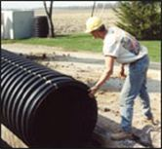
More than 40 years ago, ADS observed the cumbersome and ineffective materials being used for drainage and surface water control. Recognizing the importance of managing our nation's water resources, researched and developed a structurally superior corrugated polyethylene pipe that was perfectly suited for subsurface drainage.
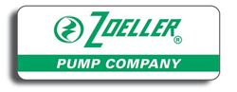
No matter what your water needs, the Zoeller family of sump pumps has the very best solution - from residential sump pumps and clean water pump solutions to commercial and municipal sump pumps engineered to exact standards. Your peace of mind is our top priority.
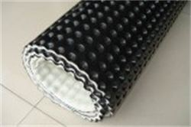

Drain Core Board is a dimpled plastic sheet that provides effective drainage and waterproof membrane protection on foundation walls and other underground structures.Drain Core Board with its dimple structure effectively captures and transports high water volumes and resists high loads from earth and formwork.
drymasterwaterproofing.com

